3.3 Company Registration DICA

ONLINE APPLICATION: MyCO (Myanmar Companies Online)

Registration can be done online at: http://www.myco.dica.gov.mm

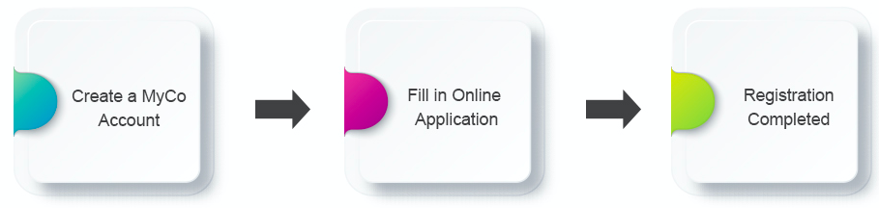

Online application:

Information needed:
 | 1 | Company Name and Details
 | 2 | Directors (Attach NRC or Passport)
 | 3 | Share Capital Structure and Members
 | 4 | Company Constitution (Myanmar Language)
Procedure:
 | 1 | Create your account at DICA MyCO website.
 | 2 | Fill in the form to register your company.
 | 3 | Complete the application and payment of fee.
Payment options:
 | – | MyCO supports credit cards and MPU cards for payment.
 | – | To pay in cash, you will need to save your application and pay at DICA office.

Procedure for establishing joint venture
Documents needed:
 | 1 | Application cover letter
 | 2 | Application form
 | 3 | List of directors/shareholders
 | 4 | Audited financial statements for the last two years
 | 5 | Credit advices relating to minimum capital brought in
 | 6 | Memorandum of Association
 | 7 | Articles of Association
 | 8 | Copies of passports of shareholders and directors’ resolution
 | 9 | Copies of passports of foreign directors or copies of NRCs of local directors
Payments: |  |  | MMK
 | 1 | Stamp tax: | 65,000 ~ 165,000
 | 2 | Registration fee: | 500,000

VISIT: for setting up a MyCO account
https://www.myco.dica.gov.mm/public/setupaccount.aspx.

--------------------------------------------------------------------------------------------------------------------------
END OF PROCEDURE 3.3

