3.4 Land Sublease Agreement KMIC

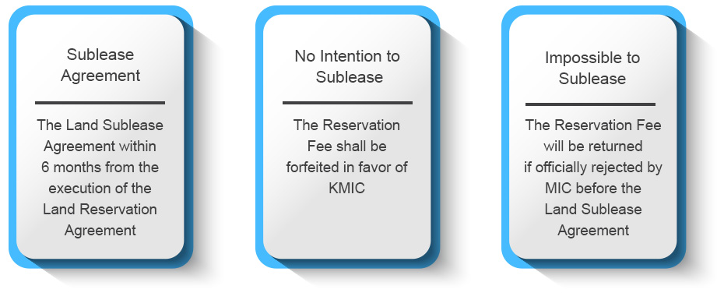

Documents needed:
 | 1 | Investment Approval
 | 2 | Land Sublease Agreement
Rental fee:
 | For entire 50-year lease period
 | The rental fee is subject to change from time to time.
Notes:
 | The Land Lease Agreement between the Investor and KMIC shall be stamped for legality and validity.
 | Necessary payment is to be made through a bank. After com-pletion of the payment, it is to be submitted to KMIC to put a stamp to the original land lease agreement before signing it.
In the event that the applicant executes the land reservation agreement with KMIC on or prior to June 30, 2021, then the Reservation Period applicable for such applicant shall be from the execution date of the land reservation agreement until the earlier of (i) December 31, 2021 or (ii) the execution date of the Land Sublease Agreement.
The Reservation Fee shall be forfeited in favor of KMIC if:
(i) the applicant, by itself or through Sublessee Entity, fails to execute the Land Sublease Agreement on or prior to the “Long Stop Date” (six (6) months from the execution date of the Land Reservation Agreement) for any reasons (other than any reason solely attributable to KMIC),
or
(ii) the applicant provides a written notice to KMIC that it is no longer pursuing its intention to sublease the Subject Lot at any time on or prior to the Long Stop Date.
In the event that the Land Sublease Agreement is executed on or before the Long Stop Date, the Reservation Fee shall be counted toward the amount of the security deposit or the first sublease fee to be payable by the applicant to KMIC under the Land Sublease Agreement.

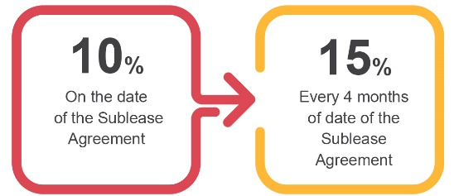
INSTALLATION PLAN

The sublease fee under the Land Sublease Agreement shall be paid in installments as follows:
(i) 10% of the total sublease fee shall be paid on the date of the execution of the Land Sublease Agreement; and
(ii) the balance of the total sublease fee shall be paid by way of installment of 15% of the total sublease fee on every four (4) months of the execution date of the Land Sublease Agreement until the total sublease fee is paid in full.
There shall be no discount on the sublease fee if any installment of the sublease fee is paid by the applicant to KMIC prior to the date on which each of the
installments is due and payable under the Land Sublease Agreement.

KMIC may terminate the Land Sublease Agreement without any liabilities if, after the execution of the Land Sublease Agreement, the applicant (i) does not or fails to obtain the MIC Approval or Other Approvals within six (6) months from the date on which the last installment under the Installment Schedule is paid in full , (ii) does not or fails to maintain the MIC Approval or Other Approvals during the sublease period, or (iii) receives an official letter from MIC or other governmental authority to the effect that the applicant is not permitted to carry out its business in the Subject Lot. Upon the termination of the Land Sublease Agreement by KMIC, any and all payments made by the applicant to KMIC under the Land Reservation Agreement and the Land Sublease Agreement up to the date of the termination of the Land Sublease Agreement, including but not limited to, the Reservation Fee, and the Sublease Fee, will be forfeited in favor of KMIC.

--------------------------------------------------------------------------------------------------------------------------
END OF PROCEDURE 3.4

